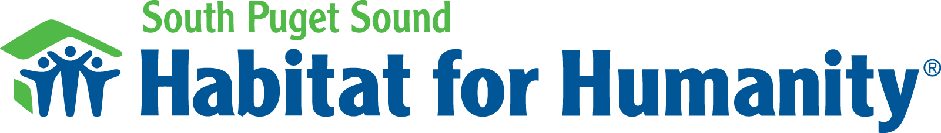

Have you ever wondered what Habitat for Humanity is all about? Get the South Puget Sound Habitat for Humanity 101 here…

South Puget Sound Habitat for Humanity 101

What is South Puget Sound Habitat for Humanity?
SPS Habitat is a local non-profit organization. Our mission is to form partnerships to build a more affordable Thurston County. We believe everyone should have a safe, decent, and affordable home.

SPS Habitat runs two programs. Our homebuyer program offers low-income households the opportunity to own an affordable, Habitat built home. Our stores offer the general public affordable building materials and home furnishings at significant discounts. SPS Habitat also participates in local community planning boards and committees to support affordable housing goals and programs in Thurston County.

What has Habitat built in Thurston County?
Since 1989, SPS Habitat has built over 50 homes across Thurston County. We are currently building our largest development to date in Lacey, where we will build 33 homes over the next 3 to 5 years. Habitat stores also divert thousands of tons from the landfill each year.

Who does South Puget Sound Habitat for Humanity serve with the homebuyer program?
Our homebuyer program is for anyone who is wants to own a Habitat home. We believe everyone should have a safe, decent, and affordable home. Our program serves individuals, families, and households of all types and compositions. Our homeowners are exceptionally diverse. Some work for Washington State agencies, local schools, and other nonprofit organizations. Some work for private businesses and a few are small business owners. Some do not work because of physical limits or age. Habitat homeowners are individuals, single-moms, single-dads, traditional and nontraditional families, and multi-generational families.

However, all Habitat homeowners must be eligible and well-qualified to own a Habitat home.

Why does Habitat build houses to buy instead of rent?
The benefits of homeownership are well-known. However, low-income households have fewer and fewer opportunities to own a home. SPS Habitat is proud to be the only affordable housing developer in Thurston County to offer low-income households an opportunity to become homeowners. We believe everyone should have an opportunity to own a home and enjoy the benefits of homeownership.

One clear benefit is equity. With every mortgage payment, homeowners earn equity and build wealth. In contrast, tenants earn no equity and build no wealth when they pay rent. Each rent payment helps the landlord get ahead; the tenant only gets by.

What is the Habitat Store?
Habitat stores offer the general public affordable building materials and home furnishings at significant discounts. The items we receive and resell help support our building program by covering our administrative and operation costs. This means that every dollar we receive from donors and through grants to build a home, builds a home. Our store covers our costs so your donations goes directly into building homes. However, we do not use materials donated to the store to build our homes. We build our homes with new, high quality materials.

What do you do with the mortgage money?
Everything contribution further our mission to build a more affordable Thurston County. Every dollar we receive from our homeowners goes back into our program. Each homeowner helps her neighbor build her home. It is a continuous cycle of paying it forward.

How often can you apply for a home?
During application phases, we usually receive 5 applications for each home we intend to build. That means most well-qualified applicants are selected when they apply. For that reason, we strongly encourage applicants to reapply if not selected the first time around.

We usually have an application phase twice a year, each lasting about 60 to 90 days. Our goal is to have our next application phase in early 2016.

What is needed to make your program work?
Funding: Building houses takes a lot of money. Habitat is a non-profit organization that runs off of donations and grants to keep our program running.

Volunteers: We can always use volunteers! Volunteering can range from helping build our homes on site to working in our store to helping with events and outreach.

