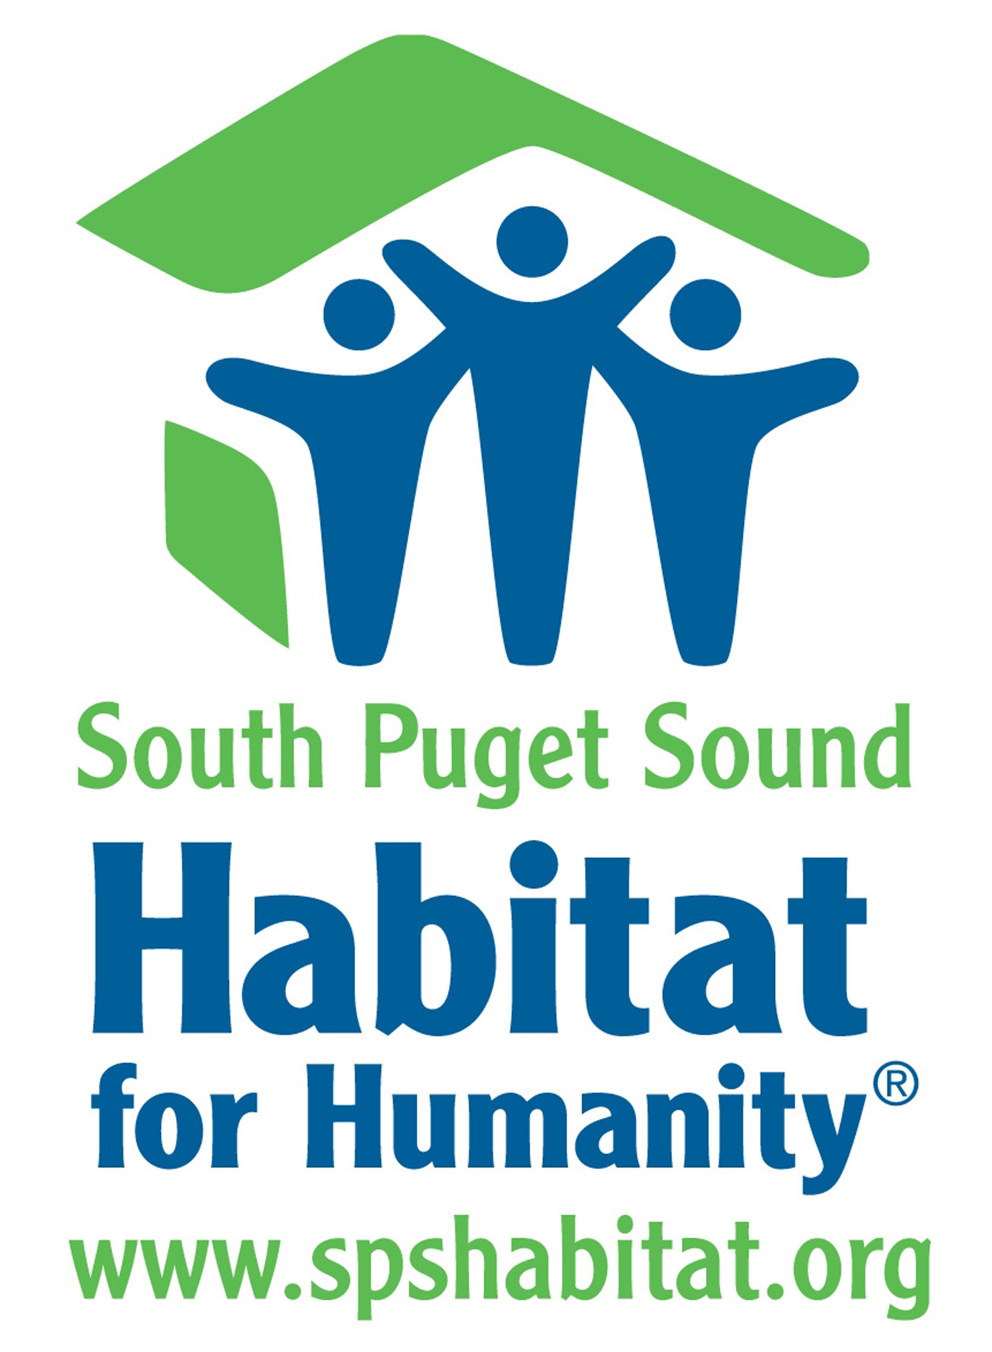

Assumption of Risk Agreement and Waiver of Liability

To be read and signed by all persons intending to do volunteer work for any of South Puget Sound Habitat for Humanity projects including home construction and Sound Builders Restore.

Building construction is a dangerous occupation. Even many professionals are injured. Worker’s Compensation rates for paid construction workers are among the highest. As a volunteer, you are not covered by Worker’s Compensation Insurance. During your volunteer activities with any of South Puget Sound Habitat for Humanity (SPSHfH) projects, if serious injury should occur that requires emergency medical assistance, you are required to report the incident to your health insurance provider first. Acordia Insurance, Habitat for Humanity International’s insurance program, will cover any excess medical expenses above and beyond your own coverage benefits. Acordia will serve as your primary coverage in the event that you do not have health/medical coverage of your own.

I acknowledge that I or my dependant(s) have voluntarily applied to participate with SPSHfH or any of its projects without pay as a volunteer.

I or my dependent(s) understand that construction is a hazardous activity. I am voluntarily participating in various activities related to the construction and demolition industry. These activities include, but are not limited to, the handling of power tools, climbing ladders, the construction of displays and merchandise, loading and unloading of materials, painting and other related activities, with the knowledge that medical facilities may not be available in the event of illness or injury to myself. This release is intended to be broad in its effect. I hereby agree to accept any and all risk of injury, illness or death and verify this statement by placing my signature below.

As consideration for being permitted to participate in these activities and have access to tools and facilitates, I hereby agree that I, any heirs, guardians and legal representatives will not make a claim against the property of SPSHfH for injury, illness or damage resulting from negligent, intentional or other acts. I hereby release SPSHfH from all actions, claims, or demands that I or my representatives now have or may hereafter have for injury, death or damage resulting from my participation in said activities.

I hereby grant and convey unto SPSHfH all right, title and interest in any and all photographic images and video or audio records made by SPSHfH during volunteer activities with SPSHfH, including, but not limited to, any royalties, proceeds, or other benefits derived from such photographs or recordings.

I understand that SPSHfH staff, volunteers, board of directors or Habitat for Humanity International, cannot be liable for any injuries or illness that I may suffer. I expressly waive any such claim for compensation or liability beyond what may be offered freely by the representative of SPSHfH in the event of such injury or medical expense.

I or my dependent(s) have carefully read this assumption of risk and fully understand its contents. I am aware that this is a release of liability and a legal contract between SPSHfH and me and that affects my legal rights. I am signing this document of my own free will.

I have read and I agree to follow South Puget Sound Habitat for Humanity’s Volunteer Rules and Procedures.

PERSON VOLUNTEERING:
Print Name: ___________________________________________________________________________
Signature: ________________________________________________________ Date: _______________

FOR MINORS:
I give permission for my dependent to work on/at any South Puget Sound Habitat for Humanity worksite.
Print Name: ___________________________________________________________________________
Signature of parent (if minor) __________________________________________ Date: ______________

CONTACT PERSON IN CASE OF EMERGENCY:
Name: ______________________________ Relationship: _______________ Phone: ________________________

Bring form to worksite or mail to: SPS Habitat for Humanity Volunteer Coordinator, 415 Olympia Ave NE, Olympia, WA 98501
Tel: (360) 956-3456 Fax (360) 956-3415 www.spshabitat.org

